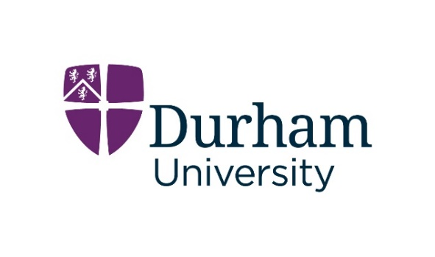
Common Awards Seedcorn Grants
Application Form
PLEASE READ THE GUIDANCE IN THE ‘CALL FOR APPLICATIONS’ DOCUMENT AVAILABLE AT
www.durham.ac.uk/departments/academic/common-awards/research/seedcorn-grant/
BEFORE COMPLETING THIS FORM

- Title (no more than 20 words)

- Principal Investigator
Name:
Institution:
Contact details:

- Institutional Information
As explained in the Call for Applications, we pay grant funds to your institution, rather than direct to you as an individual. We therefore need confirmation that someone with the authority to approve this arrangement is aware of your application and happy for you to proceed. By giving that person’s details here, you are confirming this.
Name:
Institution:
Position:
Contact details:

- Research ethics
Will your research need ethical approval? YES / NO
Have you identified where you will seek approval? YES / NO
Can you confirm that you will not proceed with any of the relevant activities until such approval has been received? YES / NO

- Brief overview (no more than 500 words)

- Proposed start date (between Sep 1st 2025 and Apr 30th 2026):

- Duration (no longer than one year):

- Full description (no more than 5000 words; there is no need to use the full 5000 if you can explain your project more concisely)
PLEASE READ THE GUIDANCE IN THE ‘CALL FOR APPLICATIONS’ DOCUMENT BEFORE COMPLETING
Objectives

Research Questions

Research Context

Research Methods

Outputs

Project Management

Project Timetable

Project Personnel

Budget

Please also include an up-to-date CV for the Principal Investigator.

Applications should be sent to common.awards@durham.ac.uk to arrive no later than
midnight on Friday March 21st 2025.

Any queries about the grants or the application process should be sent to Mike Higton, mike.higton@durham.ac.uk.

PLEASE READ THE GUIDANCE IN THE ‘CALL FOR APPLICATIONS’ DOCUMENT AVAILABLE AT
www.durham.ac.uk/departments/academic/common-awards/research/seedcorn-grant/
BEFORE COMPLETING THIS FORM

