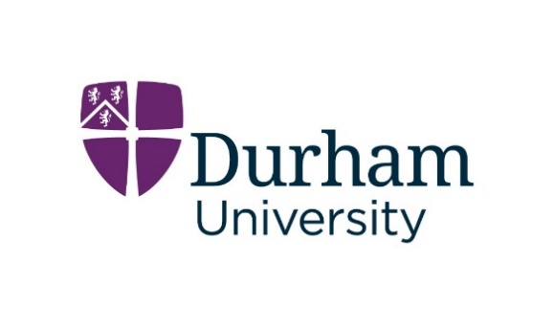
Interview Claim Form

We’d appreciate it if you could submit your expenses as soon as possible please. We will not reimburse any expenses that are submitted over 1 month after your interview date and the date on the receipts.

Please complete this interview claim form and return to us with all associated receipts.

We prefer to receive interview expense claims and receipts by email to e.recruitment@durham.ac.uk.

Alternatively, you may send your claim to us by post to:

HR Recruitment Team
Mountjoy Centre
Stockton Road
Durham University
DH1 3LE

Telephone: +44 (0) 191 334 6801

Candidate Information

Candidate Name
Candidate Address
Name of Bank
Bank Address
Account Number
Sort Code
SWIFT Code. (if applicable)
IBAN Number (EU candidates only)

Interview Details

Vacancy Reference Number
Vacancy Title and Department

Date/s of Interview

Expenditure

Expense | Date of Expense | Please provide details of the expense | Amount  £ . p | Receipt Provided (Y/N)
Travel |  |  | £
Accommodation |  |  | £
Subsistence |  |  | £
Other |  |  | £
Total Amount Claimed |  |  | £
Signature |  |  | Date

For University use only

Certified for Payment
Signature
Date
Invoice
To be completed by the Finance Department | S / F | Creditor |  | Transaction number PR | Analysis
Cost Centre | Detail Code | VAT Code |  | Value (excluding VAT) £ . p | Project
Project Analysis

